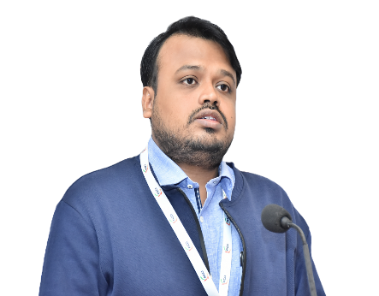
DR. DEEP CHAKRABORTY

M.Sc., Ph.D., Post-Doctorate; PGDELP

Dr. Deep Chakraborty currently holds the position of Assistant Professor, Department of Environmental Science, Amity School of Life Sciences (ASLS), Amity University Madhya Pradesh (AUMP), Gwalior, India. Formerly, he awarded the Post-Doctoral Research Associate under the Indian Council of Medical Research (ICMR, Govt. of India) and working on his research project in the field of household air pollution, public health, exposure science, health risk assessment, air pollution remediation modeling, environmental health and so on in the department of Environmental Health Engineering, Sri Ramachandra Faculty of Public Health, Sri Ramachandra Institute of Higher Education and Research.

He is also affiliated with the ICMR Centre for Advanced Research on Air Quality, Climate, and Health; and the WHO Collaborating Centre for Research & Training in Occupational and Environmental Health. He is a Life Member of the Indian Aerosol Science and Technology Association (IASTA).

He earned his Ph.D. in Environmental Science from The University of Burdwan, Department of Environmental Science, West Bengal. He completed his first post-doctoral degree at the Sri Ramachandra Institute of Higher Education and Research. He also graduated from National Law University in Delhi with a Post-Graduate in Environmental Law and Policy.

He has over 10 years of research and academic experience in the field of Environmental Science, Environmental Health, Risk Assessment, Exposure Monitoring, Indoor Air Quality Modelling, Environmental Chemistry, Indoor Microbiology, Ecology, and Environmental Law. He has published over 30 research publications in prestigious international and national journals on environmental science and health to date.

He has been felicitated Four times for the outstanding scientific research and development in the field of Environmental Science from the Department of Science & Technology and Biotechnology, Govt. of West Bengal.

To date, he has been associated with four interdisciplinary research projects and has communicated three project proposals to different funding agencies. He has attended more than 30 international and national conferences, seminars, and workshops. He has served as a reviewer of various international and national journals. He also has served as an invited speaker in various scientific institutes. He is also serving as an advisory board member in various scientific communities.

